Session 20116 to 2017 was an eventful period in the history of The Glasgow Hammermen with the notable visit by HRH the Duke of Edinburgh K.G., K.T. who has been an Honorary Member of The Glasgow Hammermen since 1955. HRH Price Philip supported an annual prize in his name to be given to deserving trainees in the industries associated with Hammermen whether at crafts level, or those in further and higher education since the first prise was awarded in 1967.
Normally the Prince Philip Prizes are awarded during the Hammermen’s Annual Dinner in November but with this welcome opportunity of his visit to Glasgow a special event was held on 3rd of July 2017. Together with other worthy events through the 2016-17 session with Deacon John A McKnight in post the following photographic record has been compiled and it will be recorded in the Hammermen archives for the ongoing history of the Incorporation.

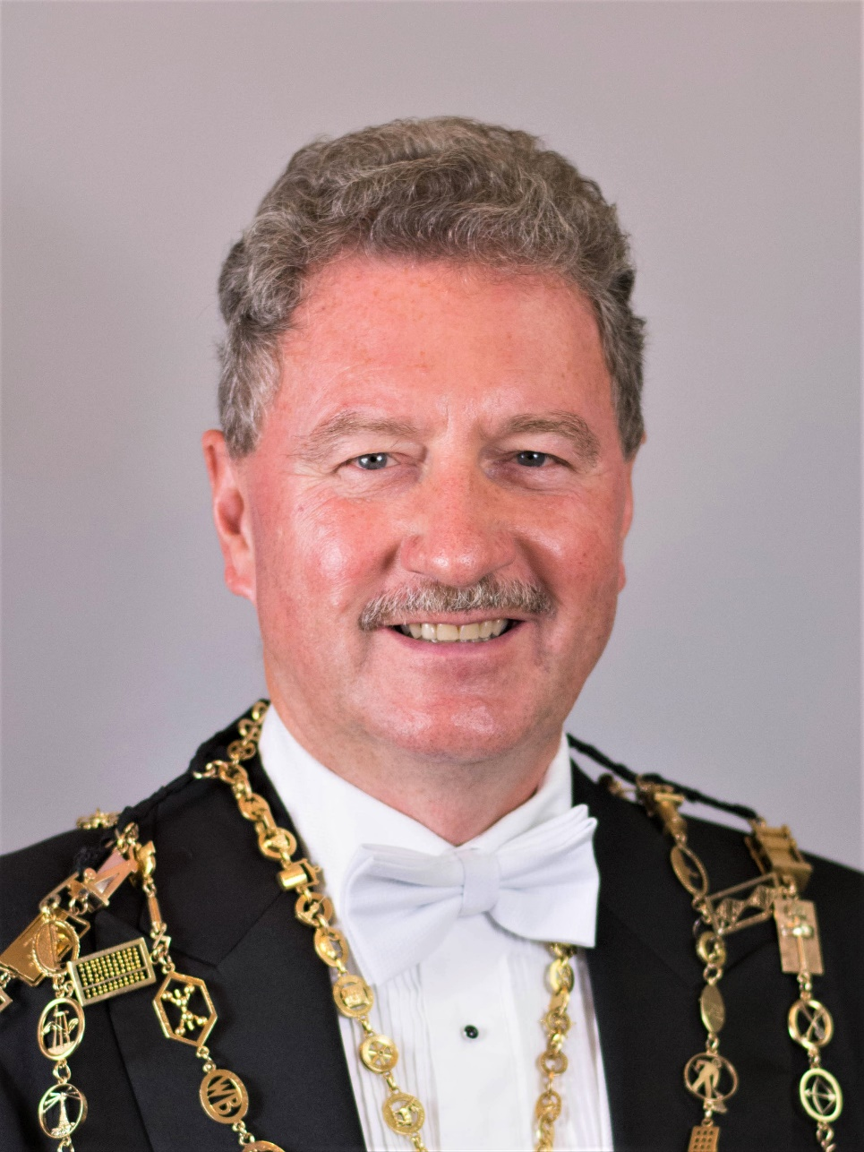
Deacon John A McKnight
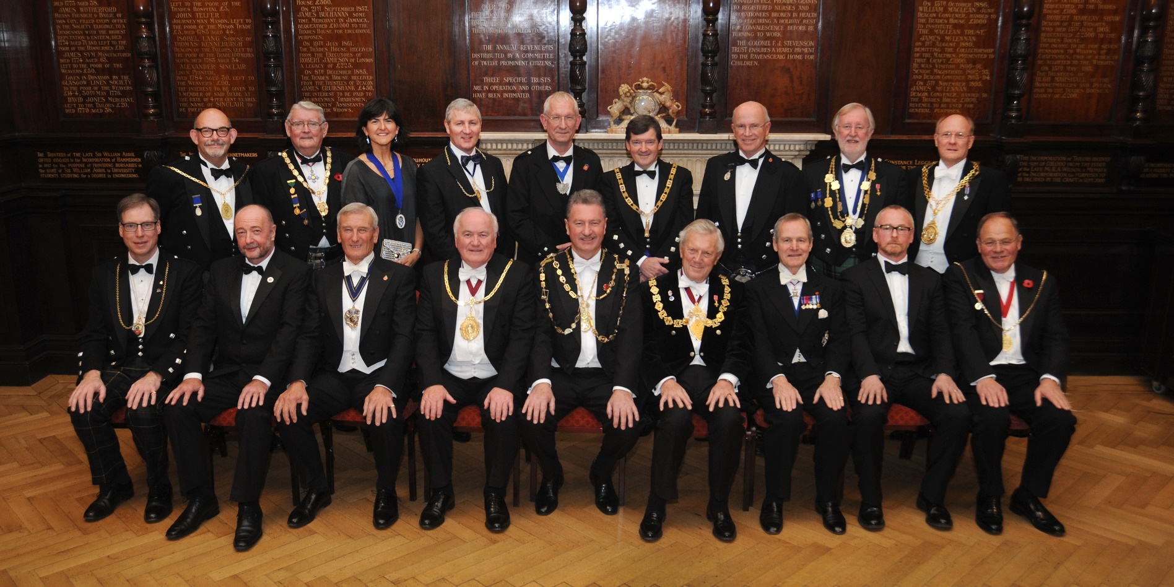
Annual Dinner 10 November 2016 - Top Table Guest’s
(Front Row from the left, Lord Dean of Guild John MacLeod, Guest Speaker Bryan Buchan, Master of the Worshipful Company of Pewterer’s Roderick Kent, Collector of the House Tom McInally, Deacon of the Hammermen of Glasgow John A McKnight, Deacon Convener of the Trades of Glasgow Keith Brown OBE, Prime Warden of the Worship Company of Shipwrights Rear Admiral Sir Jeremy de Halpert KCVO CB, Guest Speaker Andy Scott and Preses of the Grand Antiquity Society of Glasgow Graeme Kidd.
Back Row from the left, Deacon of the Cordiners Adrian Pierotti, President of the Association of Deacons Derek Mason, President of IESIS Karen Dinardo ,Deacon of the Paisley Hammermen Society Eric Robertson, Deacon of the Edinburgh Hammermen Alan Dickson, RWM of the Trades House Lodge Alasdair Beaton, Late Collector of the Coordiners Dr Iain Lennox, Preses of the Weavers Society of Anderston Ian Young OBE and Deacon of the Govan Weavers Norman Hamilton IF.)
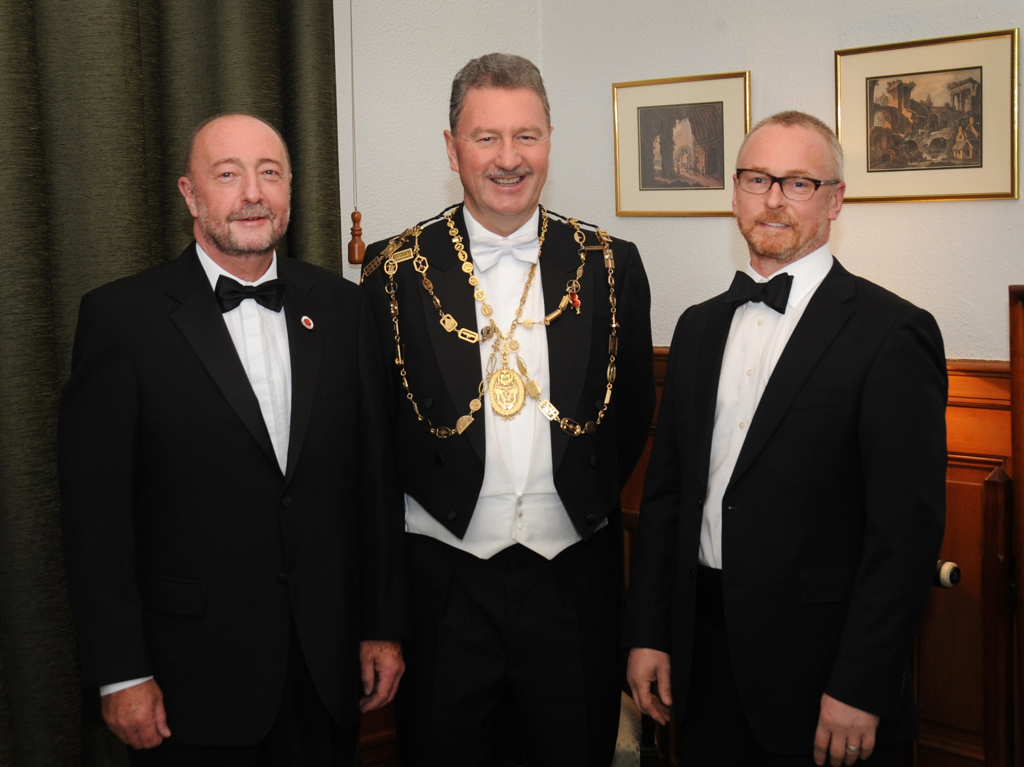
Annual Dinner 10 November 2016 - Guest Speakers
(From the left, Guest Speaker CEO of Scottish Engineering Bryan Buchan, Deacon John A McKnight, Guest Speaker Andy Scott, Sculptor and creator of ‘the Kelpies’)
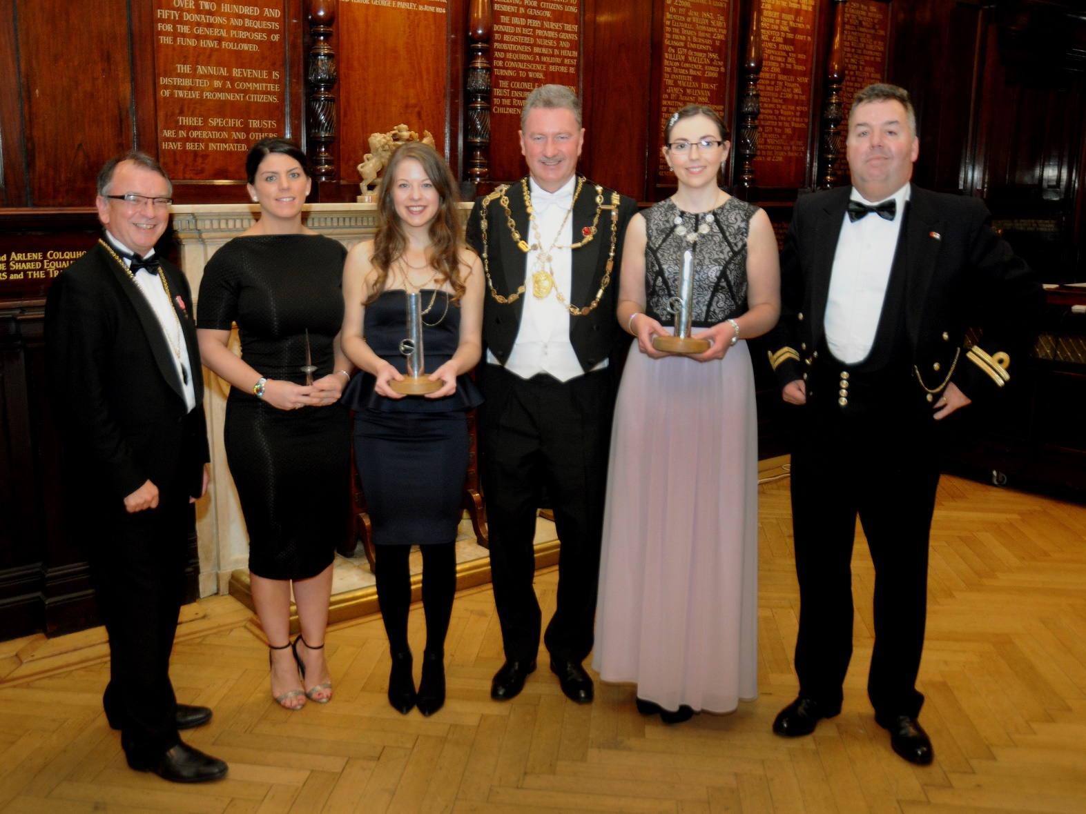
Annual Dinner 10 November 2016 – Prize winners
(From the left, Collector Professor Gordon Masterton OBE, Scottish Engineering Prize winner Ashley Nicolson, Prince Philip Prize winner Ellen Simmons, Deacon John A McKnight, Prince Philip Prize winner Katie Lyon and Late Collector Colin Botfield.)
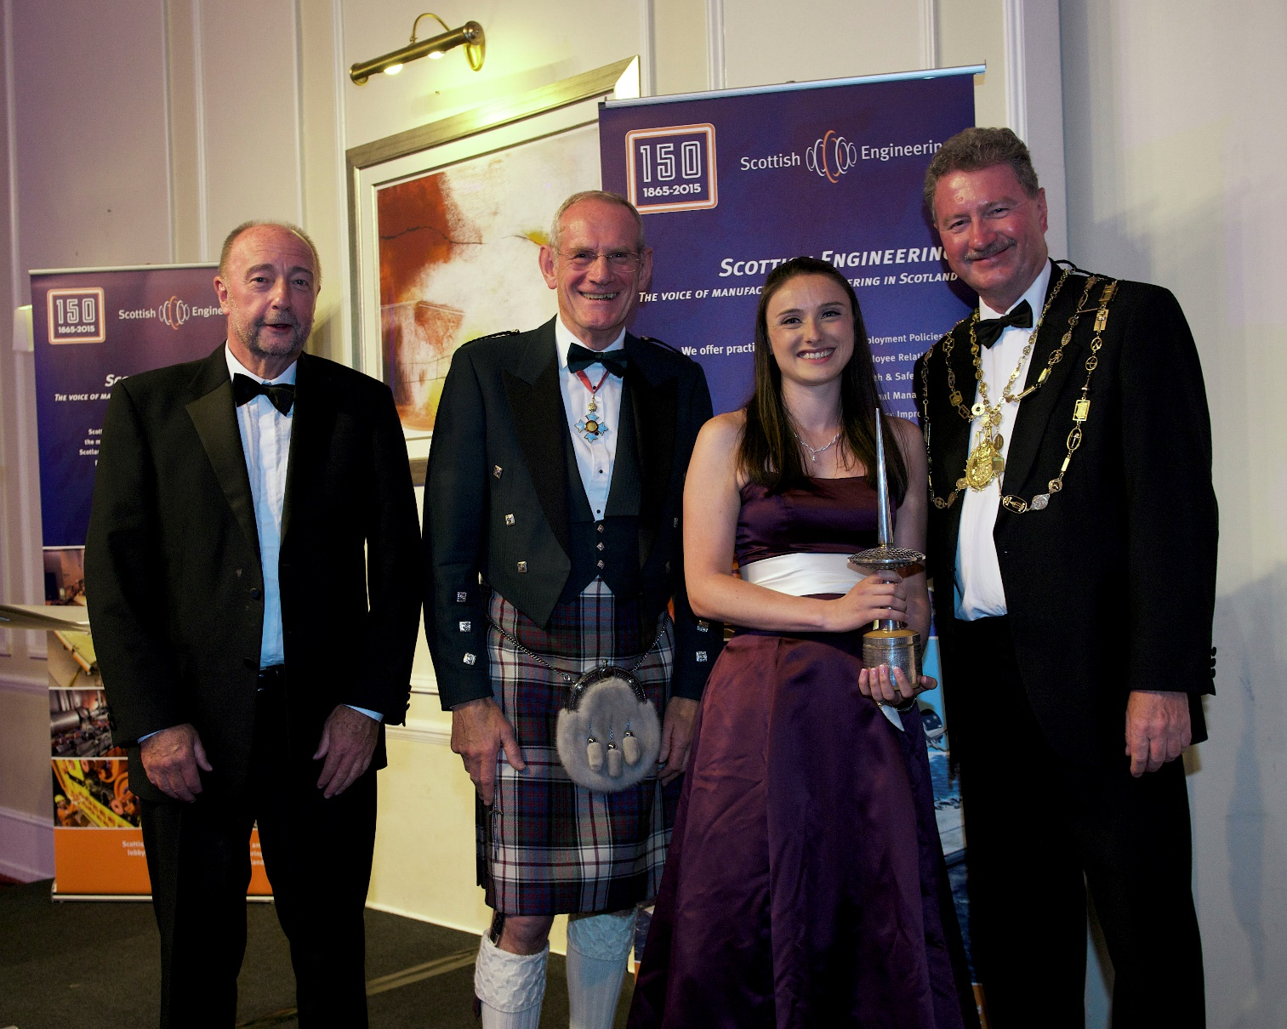
Scottish Engineering Dinner 18 May 2017 - Prize Presentation
(From the left, CEO of Scottish Engineering Bryan Buchan, Guest Speaker John Baxter, 2017 Prize winner Meryl Devlin and Deacon John A McKnight.)
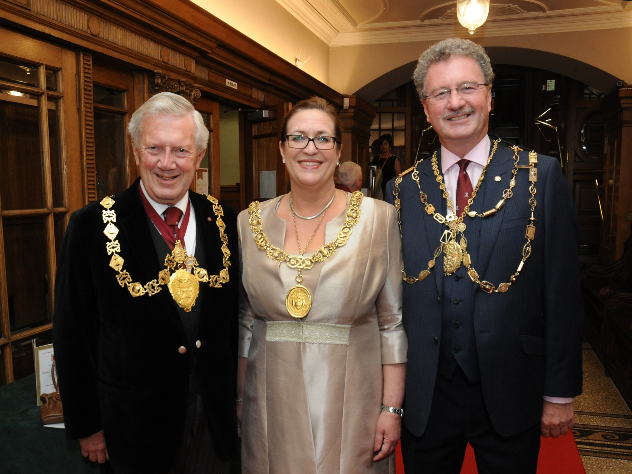
Prince Philip 50th Anniversary Reception 3 July 2017 - HRH Reception Group
(From the left, Deacon Convener of the Trades of Glasgow Keith Brown OBE, Lord Provost of Glasgow Eva Bolander and Deacon John A McKnight.)
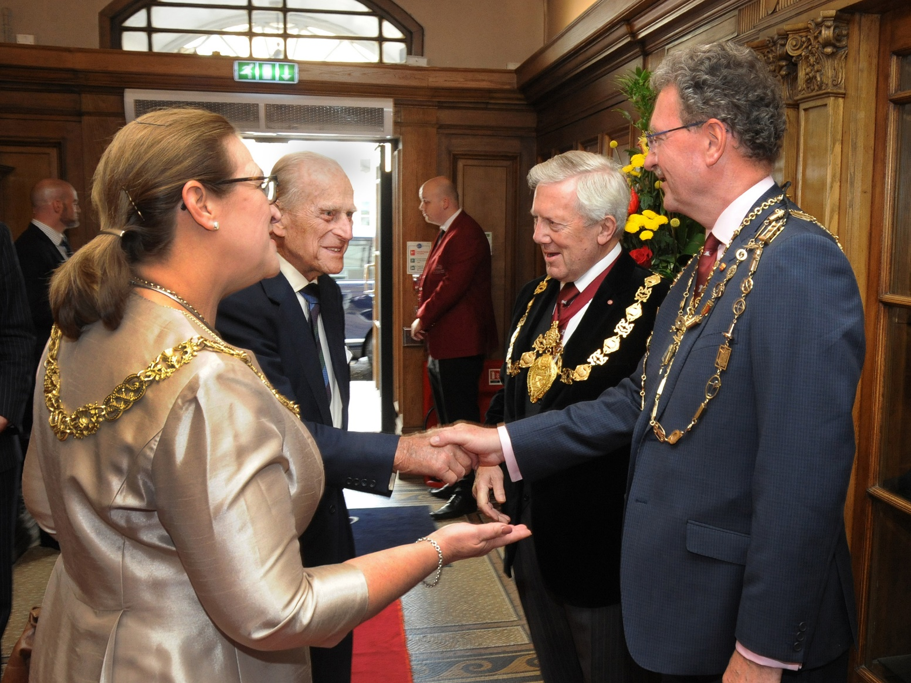
Prince Philip 50th Anniversary Reception 3 July 2017 - HRH Arrival
(From the left, Lord Provost Eva Bolander, HRH The Duke of Edinburgh K.G., K.T., Deacon Convener Keith Brown OBE and Deacon John A McKnight welcomes HRH to the PPP 50th Anniversary Reception at the Trades House of Glasgow.)
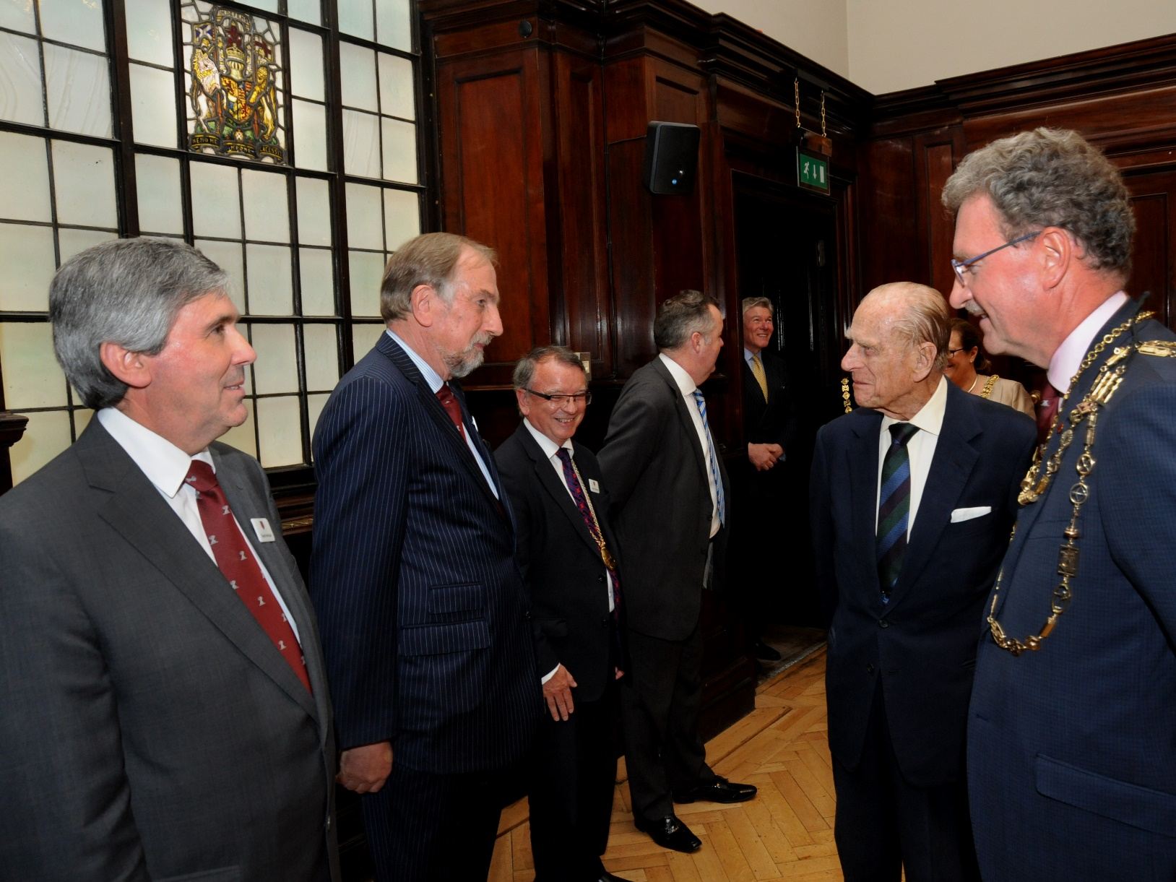
Prince Philip 50th Anniversary Reception 3 July 2017- HRH Meeting the Master Court
(Deacon John A McKnight presents Members of the Master Court to HRH, The Duke of Edinburgh K.G., K.T. in the Saloon of the Trades Hall.)
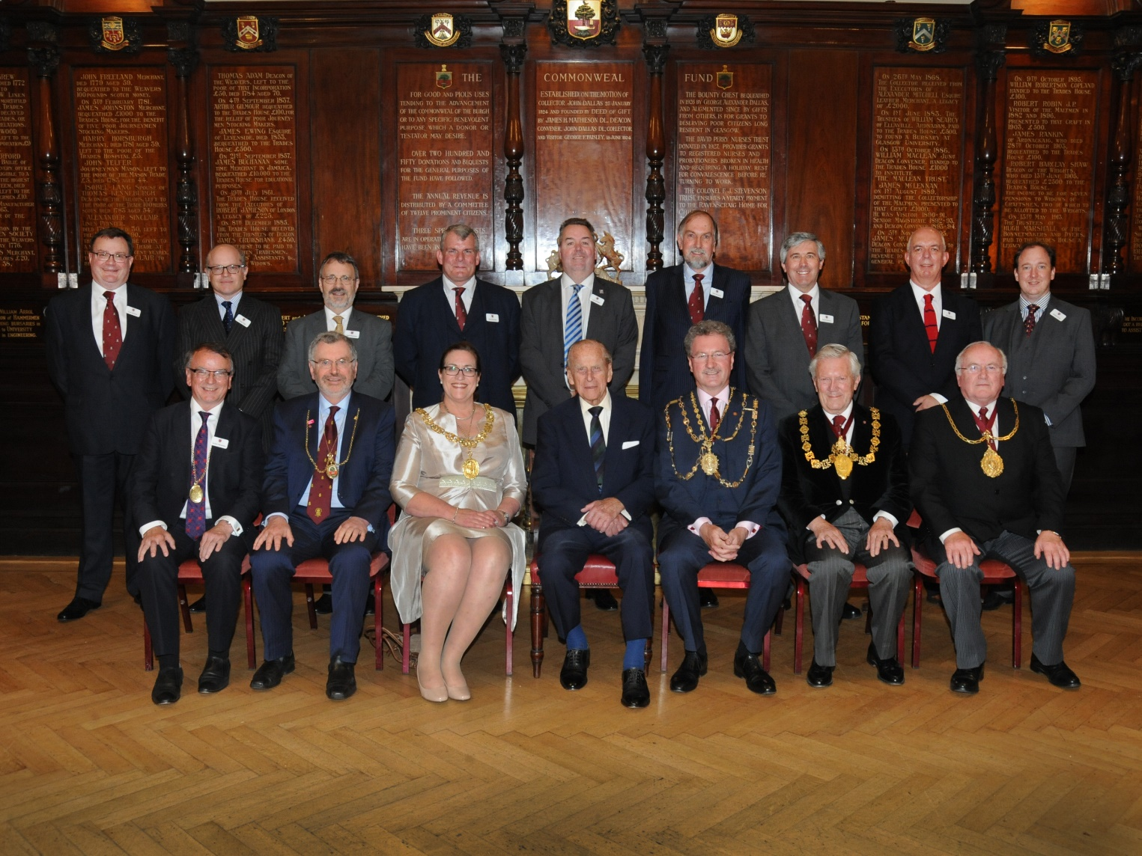
Prince Philip 50th Anniversary Reception 3 July 2017- Commemorative Group
(Front Row from the left, Collector Professor Gordon Masterton OBE, Lord Dean of Guild Ian Dickson BEM DL, Lord Provost of Glasgow Eva Bolander, HRH The Duke of Edinburgh K.G., K.T., Deacon John A McKnight, Deacon Convener of the Trades of Glasgow Keith Brown OBE and Collector of the House Tom McInally
Back Row from the left, Clerk to the Hammermen, Grant Johnston, Members of the Master Court, Charles Craig, David Westmore, Ex Deacon David Denholm, Late Collector Colin Botfield, Late Deacon Peter McCarthy, Ex Deacon David Harrison, Bruce Wood and Andrew Young.)
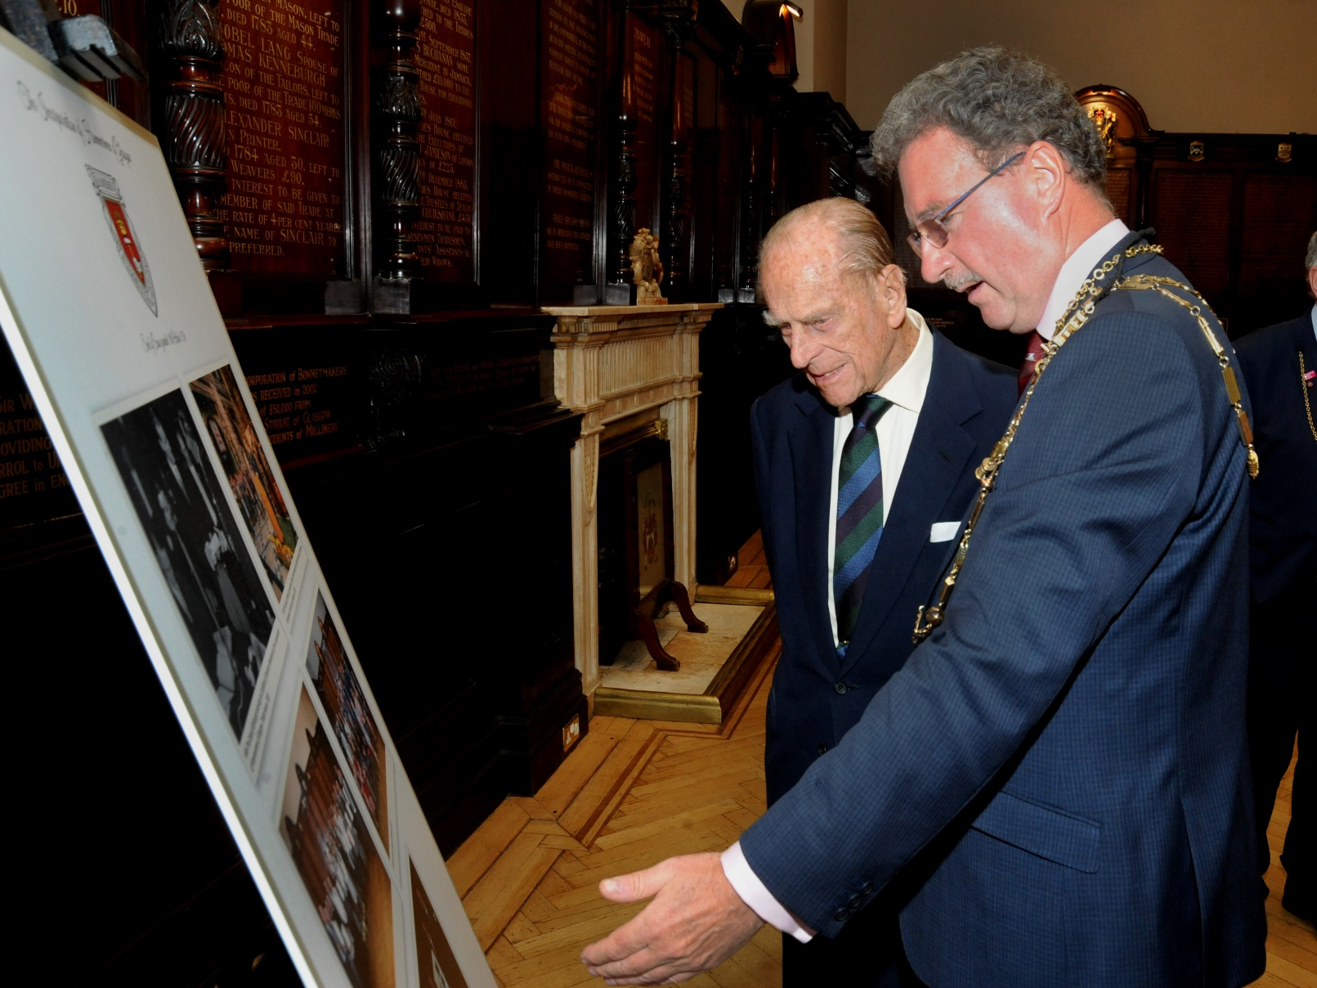
Prince Philip 50th Anniversary Reception 3 July 2017 – HRH views Commemorative Photographs.
(Deacon John A McKnight showing HRH commemorative photographs of HRH joining the Incorporation in 1955 together with his other visits to the Craft.)
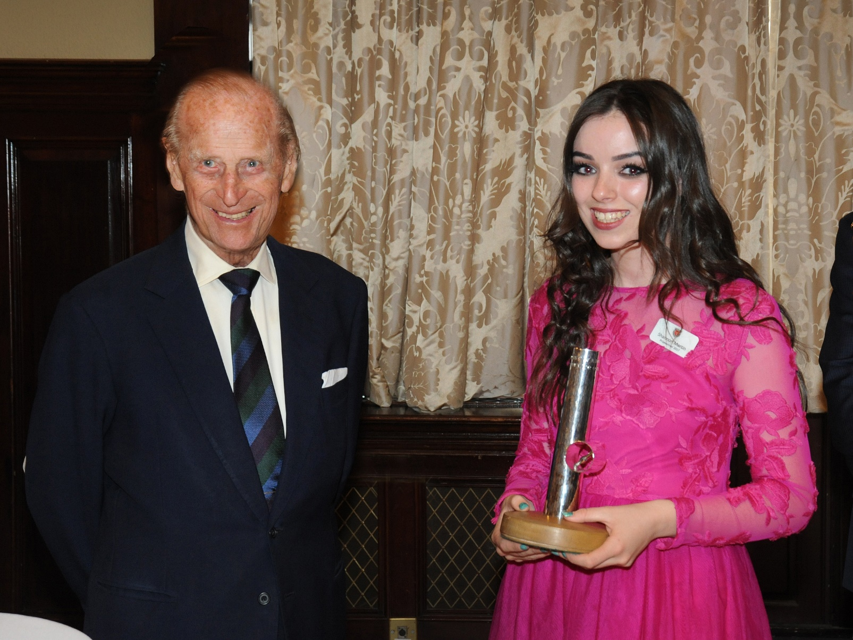
Prince Philip 50th Anniversary Reception 3 July 2017 Prize Presentation
(HRH, the Duke of Edinburgh K.G., K.T. presenting the 2017 Prince Philip Prize for the College Category to Shannon Martin of Glasgow Clyde College, Langside Campus.)
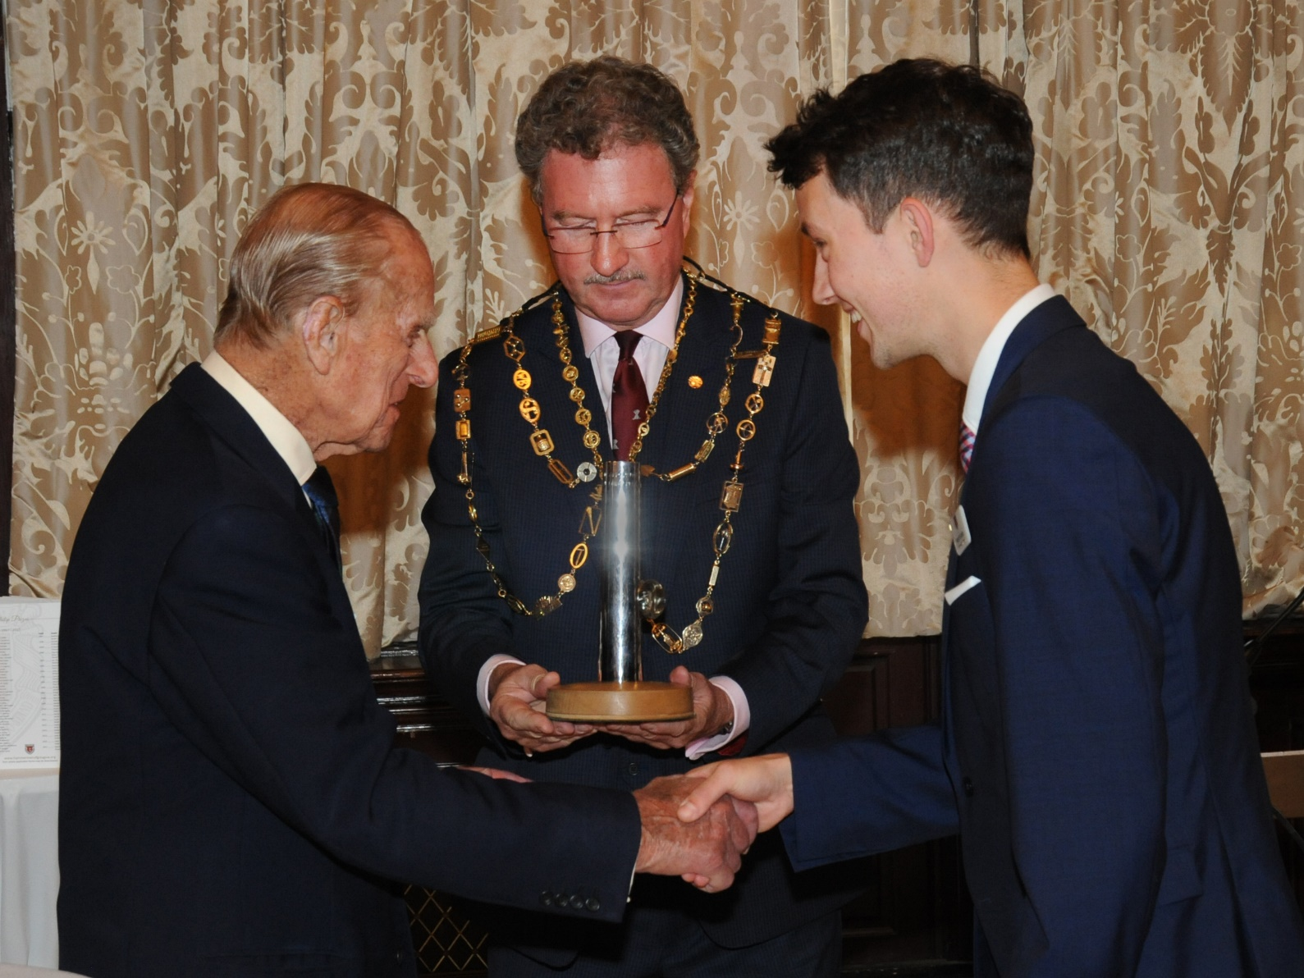
Prince Philip 50th Anniversary Reception 3 July 2017 Prize Presentation.
(HRH, the Duke of Edinburgh K.G., K.T. presenting the 2017 Prince Philip Prize for the University Category to Merlin Kafka of Strathclyde University.)
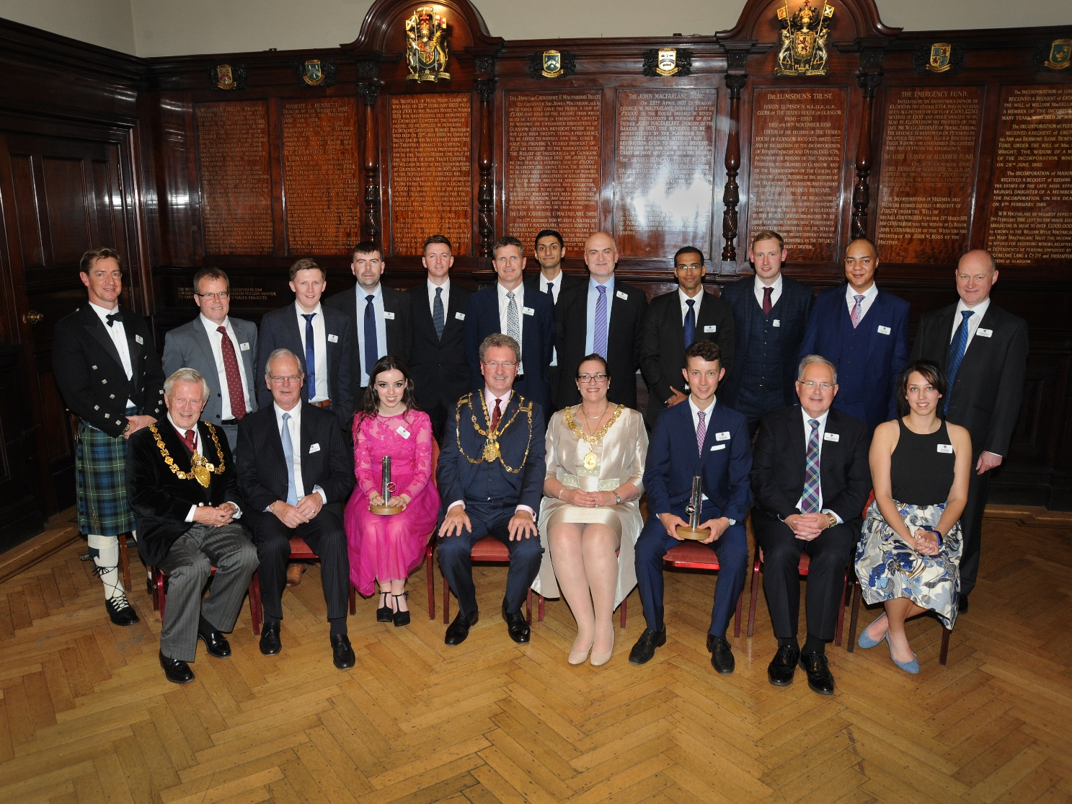
Prince Philip 50th Anniversary Reception 3 July 2017 Group Photograph.
(Front row from the left, Deacon Convener Keith Brown OBE, Stuart Cameron Past Prize Winner, Shannon Martin Prize Winner 2017, Deacon John A McKnight, Lord Provost of Glasgow Eva Bolander, Merlin Kafka Prize Winner 2017, Gordon MacLennan Past Prize Winner and Amy Keenan Past Prize Winner.
Back Row, Past Prize Winners of the Prince Philip Prizes.)

